Question 1 (6 marks)

Function is defined with domain by .

(a) Determine . (2 marks)

Function is defined with domain by .

(b) State the range of . (1 mark)

(c) Determine the range of . (3 marks)

Question 1 (6 marks)

Function is defined with domain by .

(a) Determine . (2 marks)

|  |
| --- |
| Solution |
| Hence . |
| Specific behaviours |
| ✓ reasonable attempt using any correct method  ü correct value |

Function is defined with domain by .

(b) State the range of . (1 mark)

|  |
| --- |
| Solution |
| *Range of equals domain of* |
| Specific behaviours |
| ü correct range, using any notation |

(c) Determine the range of . (3 marks)

|  |
| --- |
| Solution |
| Domain of is range of . As increases from to , is always increasing and so range will be from to : |
| Specific behaviours |
| ✓ indicates increasing over domain, or boundaries required  ü obtains one boundary  ü correctly writes range |

Question 3 (7 marks)

Let .

(a) Sketch the graph of . (1 mark)

<EFOFEX>
id:fxd{42acc2e6-8b34-466a-8ec0-01b4836e03eb}

FXData:

</EFOFEX>

(b) On the axes below, sketch the graph of . (2 marks)

<EFOFEX>
id:fxd{5b9935d9-2761-453a-9cee-2c8cd5514297}

FXData:

</EFOFEX>

Consider .

(c) Briefly describe how the graph of can be used to sketch the graph of and hence state the domain and range of . (4 marks)

Question 3 (7 marks)

Let .

(a) Sketch the graph of . (1 mark)

<EFOFEX>
id:fxd{272c59fc-dc91-45d7-ac6d-49a43757fc0e}

FXData:

</EFOFEX>

|  |
| --- |
| Solution |
| See graph |
| Specific behaviours |
| ✓ reasonable sketch |

(b) On the axes below, sketch the graph of . (2 marks)

<EFOFEX>
id:fxd{7c3aa8ab-e384-4bb7-a53f-8dba58993e15}

FXData:

</EFOFEX>

|  |
| --- |
| Solution |
| See graph |
| Specific behaviours |
| ✓ symmetry about -axis  ü correct sketch |

Consider .

(c) Briefly describe how the graph of can be used to sketch the graph of and hence state the domain and range of . (4 marks)

|  |
| --- |
| Solution |
| The graph of is the same as the graph of .  Domain .  Range . |
| Specific behaviours |
| ✓ explains is reciprocal of  ü correct restrictions on for domain  ü states component of range  ü states component of range |

Question 5 (7 marks)

Functions and are defined by , and .

(a) Determine the defining rule for and state its domain. (4 marks)

(b) Determine the defining rule for and state its range. (3 marks)

Question 5 (7 marks)

Functions and are defined by , and .

(a) Determine the defining rule for and state its domain. (4 marks)

|  |
| --- |
| Solution |
| Note, .  When , the radicand will always be positive.  When , require radicand to be positive:  Hence domain: |
| Specific behaviours |
| ✓ defining rule  ü domain excludes zero  ü domain allows all  ü domain allows all |

(b) Determine the defining rule for and state its range. (3 marks)

|  |
| --- |
| Solution |
| Inverse:  Range of inverse same as domain of function: |
| Specific behaviours |
| ✓ swaps variables and eliminates root  ü correct inverse  ü uses domain from part (a) for range of inverse |

Question 7 (6 marks)

The functions and are polynomials in of degree two and degree one respectively, and their quotient is the rational function .

The graph of passes through the point , has vertical asymptote and has roots at and .

Determine the equation of the other asymptote of the graph of .

Question 7 (6 marks)

The functions and are polynomials in of degree two and degree one respectively, and their quotient is the rational function .

The graph of passes through the point , has vertical asymptote and has roots at and .

Determine the equation of the other asymptote of the graph of .

|  |
| --- |
| Solution |
| Using roots:  Using asymptote:  Hence  Using point:  Hence  Express as proper fraction:  Hence equation of oblique asymptote: |
| Specific behaviours |
| ✓ uses roots to obtain factors of  ü uses vertical asymptote to obtain  ü uses point to obtain constant  ü indicates correct  ü expresses as proper fraction  ü states correct equation for asymptote |

Question 2 (6 marks)

The function is defined by . The graph of is shown below.

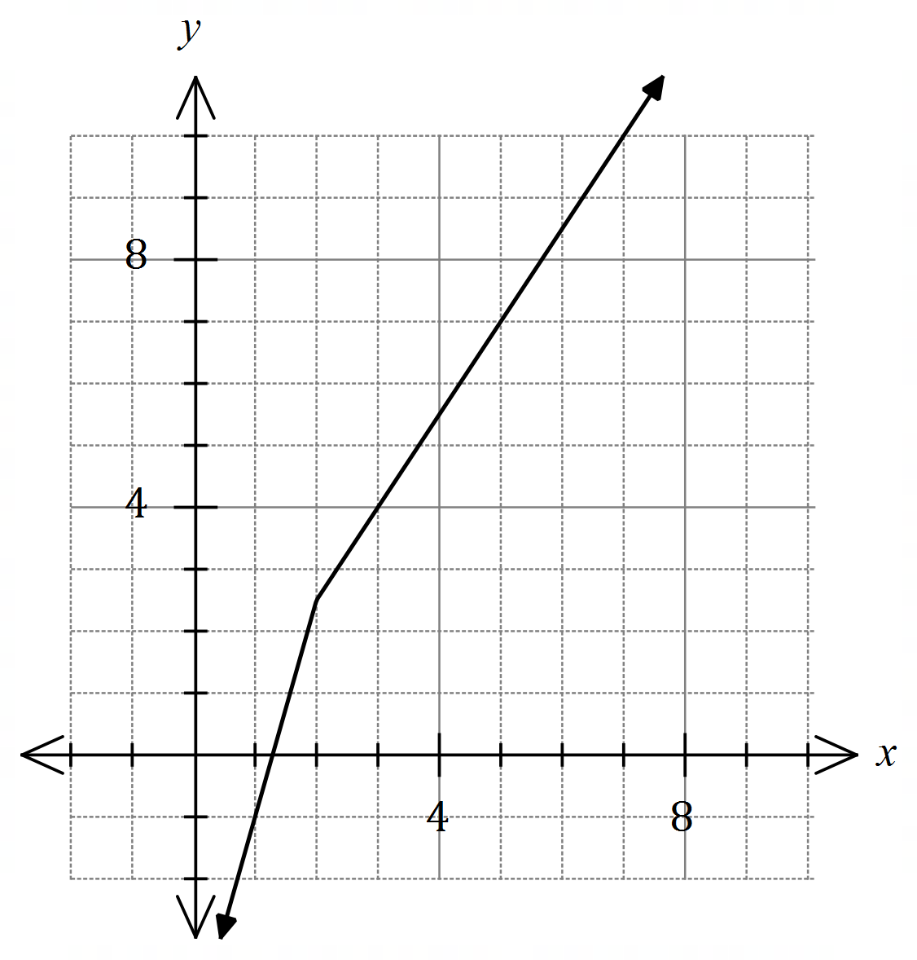

(a) State the value of . (1 mark)

(b) Sketch the graph of on the axes above. (2 marks)

(c) Solve . (3 marks)

Question 2 (6 marks)

The function is defined by . The graph of is shown below.

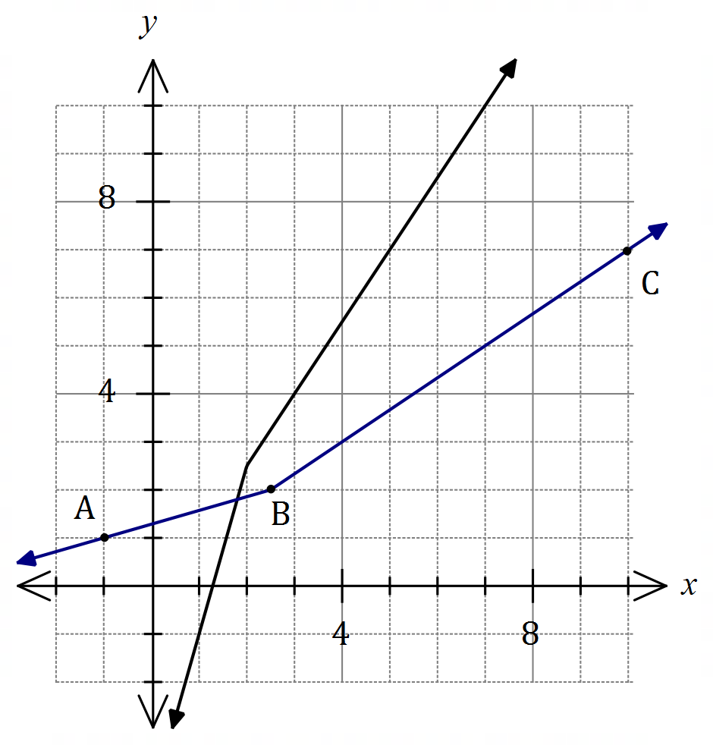

|  |
| --- |
| **Solution (b)** |
| See graph |
| **Specific behaviours** |
| ✓ segment  ✓ segment |

(a) State the value of . (1 mark)

|  |
| --- |
| **Solution** |
|  |
| **Specific behaviours** |
| ✓ correct value |

(b) Sketch the graph of on the axes above. (2 marks)

(c) Solve . (3 marks)

|  |
| --- |
| **Solution** |
| Intersect on the line when and so |
| **Specific behaviours** |
| ✓ simplifies required part of  ✓ indicates solution will lie on  ✓ correct solution |

Question 3 (8 marks)

The function is defined by .

(a) Determine the range of . (3 marks)

The function is defined by .

(b) Determine an expression for . (2 marks)

(c) Determine the domain and range of . (3 marks)

Question 3 (8 marks)

The function is defined by .

(a) Determine the range of . (3 marks)

|  |
| --- |
| **Solution** |
| has minimum at |
| **Specific behaviours** |
| ✓ differentiates or completes square  ✓ shows minimum within defined domain of  ✓ correct range |

The function is defined by .

(b) Determine an expression for . (2 marks)

|  |
| --- |
| **Solution** |
|  |
| **Specific behaviours** |
| ✓ indicates correct method  ✓ correct composite function, simplified |

(c) Determine the domain and range of . (3 marks)

|  |
| --- |
| **Solution** |
| Radicand of has minimum when . |
| **Specific behaviours** |
| ✓ indicates maximum of when radicand minimum  ✓ correct range of composite function  ✓ correct domain |

Question 4 (7 marks)

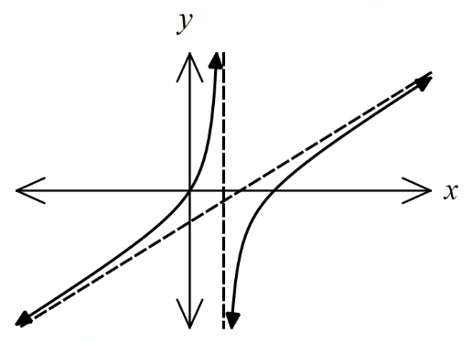Let .

The graph of is shown at right.

(a) Determine the equation of each asymptote shown on the graph of . (3 marks)

(b) On the axes below, sketch the graph of . (4 marks)

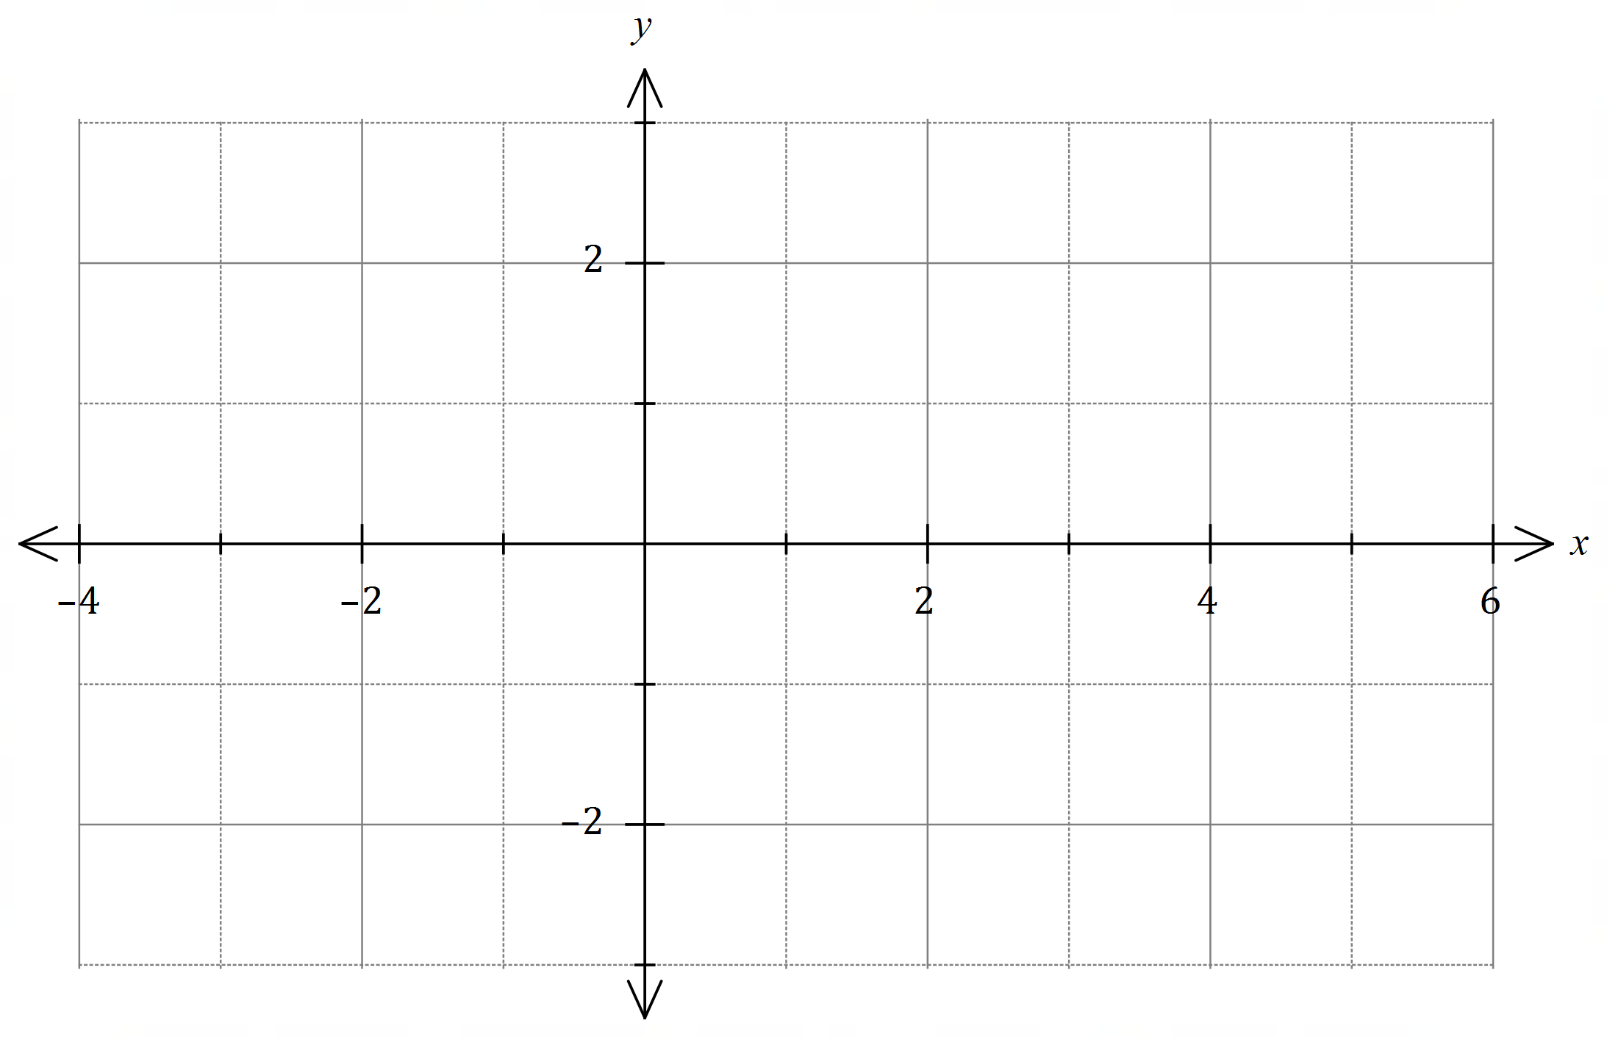

Question 4 (7 marks)

Let .

The graph of is shown at right.

(a) Determine the equation of each asymptote shown on the graph of . (3 marks)

|  |
| --- |
| **Solution** |
| Asymptotes: and . |
| **Specific behaviours** |
| ✓ attempts to write to expose slanted asymptote  ✓ correct slant asymptote  ✓ vertical asymptote |

(b) On the axes below, sketch the graph of . (4 marks)

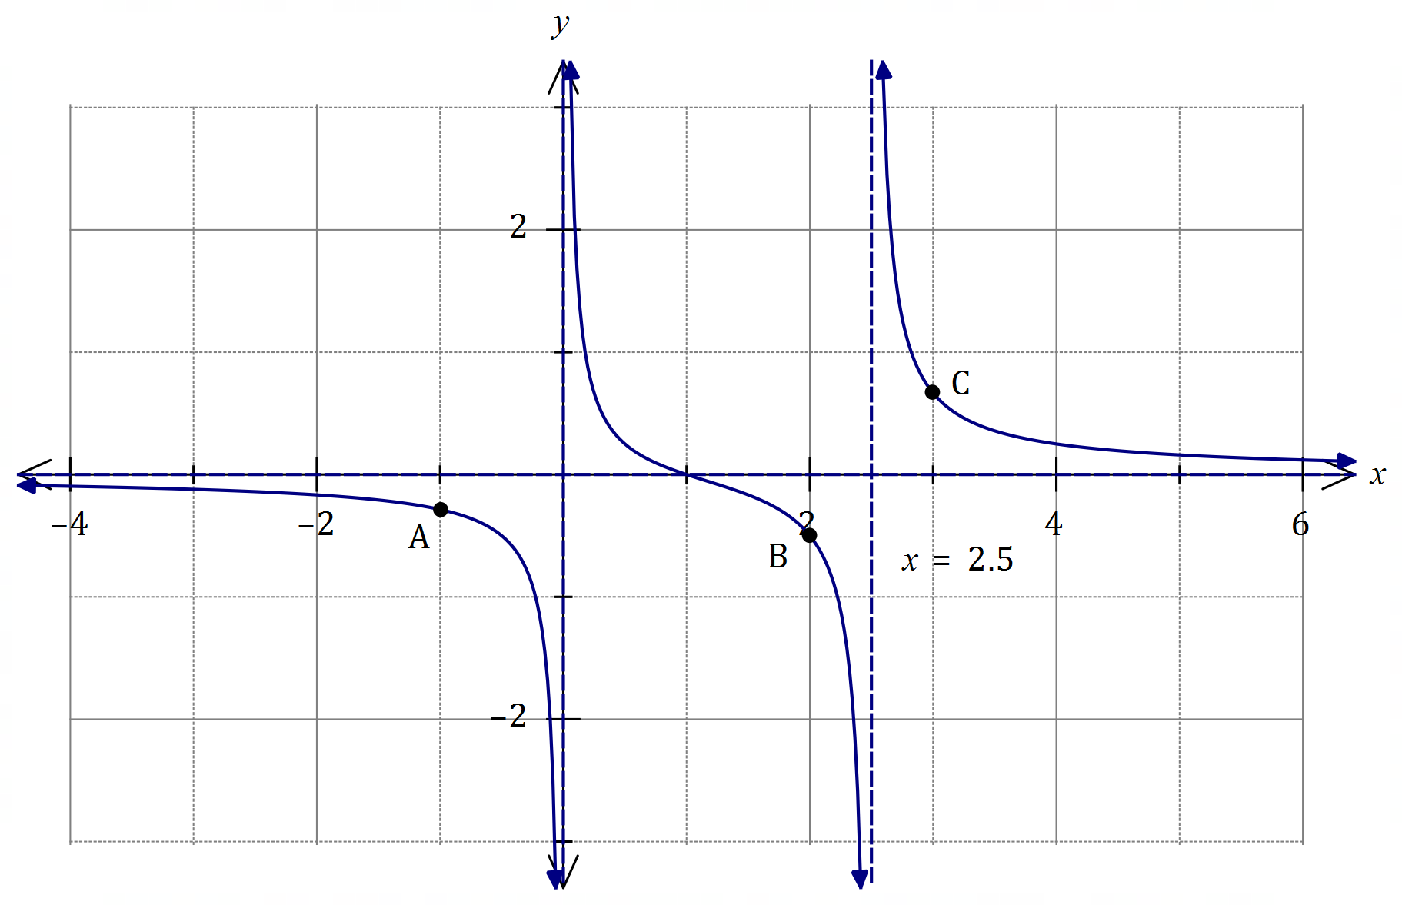

|  |
| --- |
| **Solution** |
| See graph |
| **Specific behaviours** |
| ✓ asymptotic behaviour to L of  ✓ asymptotic behaviour to R of  ✓ asymptotic behaviour between and  ✓ through and close to , and |

Question 5 (5 marks)

Use the substitution to evaluate

|  |
| --- |
| **Solution** |
|  |
| **Specific behaviours** |
| ✓ obtains in terms of  ✓ changes limits  ✓ simplifies integrand  ✓ antidifferentiates integrand  ✓ evaluates definite integral |

Question 1 (6 marks)

Let .

(a) Sketch the graph of on the axes below. (2 marks)

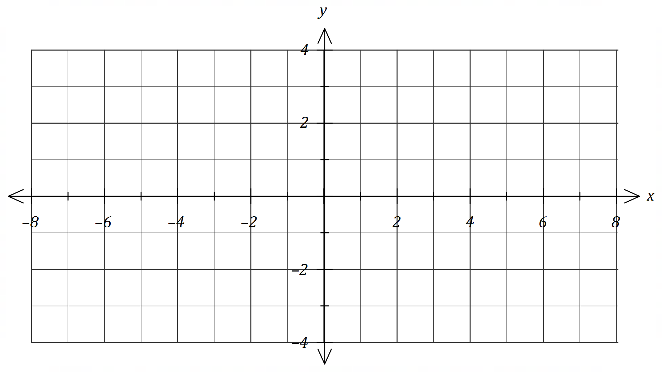

(b) On the same axes, sketch the graph of . (3 marks)

(c) Determine all solutions to the equation . (1 mark)

Question 1 (6 marks)

Let .

(a) Sketch the graph of on the axes below. (2 marks)

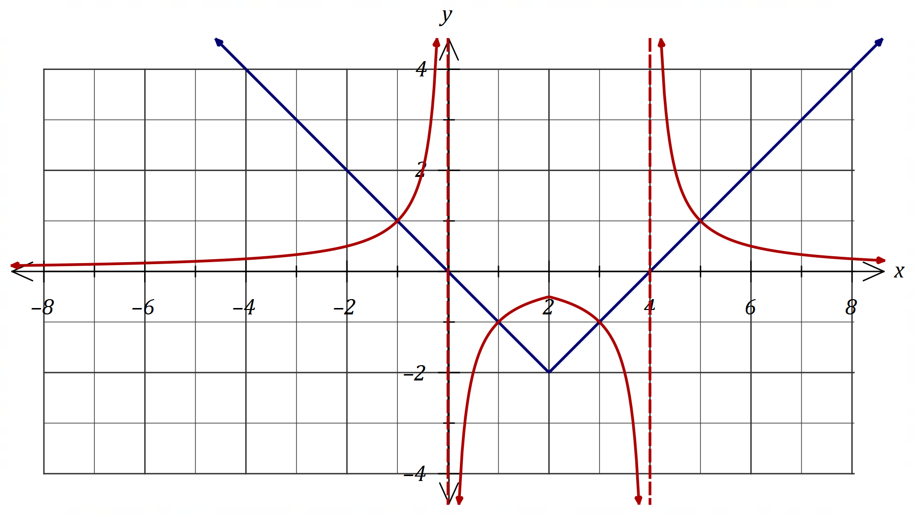

|  |
| --- |
| **Solution (a)** |
| See graph |
| **Specific behaviours** |
| ✓ cusp and roots  ✓ ruled lines |

|  |
| --- |
| **Solution (b)** |
| See graph |
| **Specific behaviours** |
| ✓ asymptotes  ✓ curve between asymptotes  ✓ curves outside asymptotes |

(b) On the same axes, sketch the graph of . (3 marks)

(c) Determine all solutions to the equation . (1 mark)

|  |
| --- |
| **Solution** |
|  |
| **Specific behaviours** |
| ✓ all solutions |

Question 3 (6 marks)

Functions and are defined as , and .

(a) Determine the defining rule for and its domain. (2 marks)

(b) Determine an expression for and its domain and range. (4 marks)

Question 3 (6 marks)

Functions and are defined as , and .

(a) Determine the defining rule for and its domain. (2 marks)

|  |
| --- |
| **Solution** |
|  |
| **Specific behaviours** |
| ✓ defining rule  ✓ domain |

(b) Determine an expression for and its domain and range. (4 marks)

|  |
| --- |
| **Solution** |
|  |
| **Specific behaviours** |
| ✓ expression for  ✓ lower bound, inequality for domain  ✓ upper bound, inequality for domain  ✓ range |

Question 6 (9 marks)

The graph of and its two asymptotes is shown below.

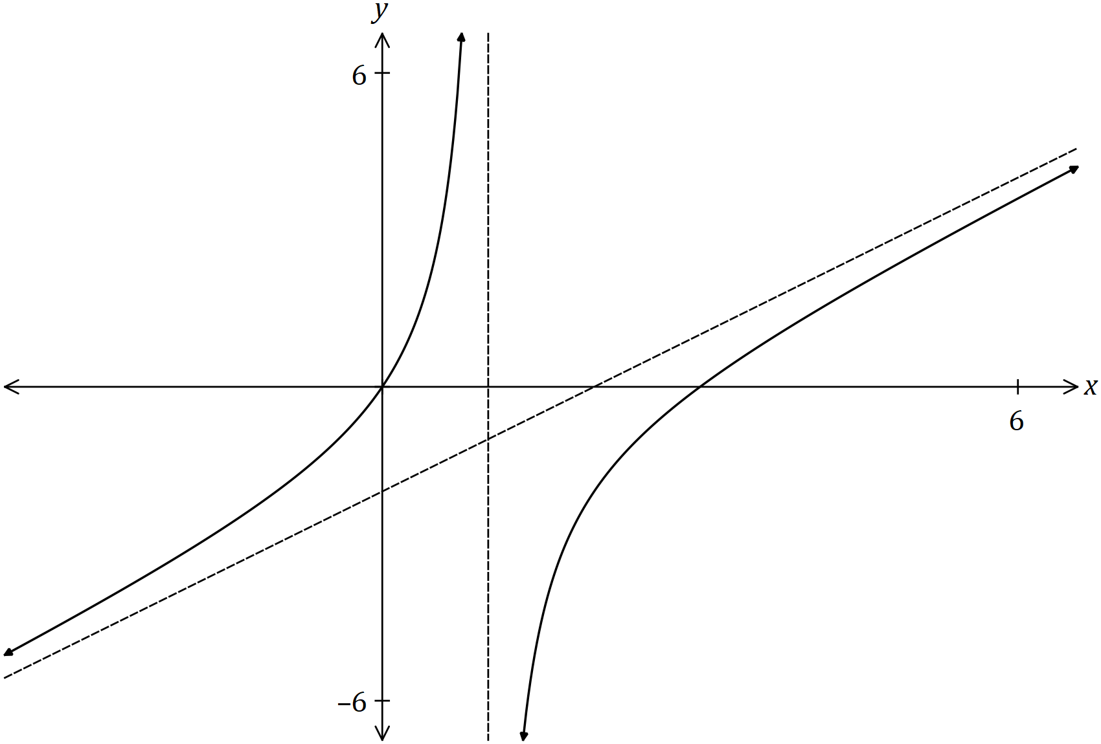

(a) Determine the equation of both asymptotes. (3 marks)

(b) On the axes below, sketch the graph of . (4 marks)

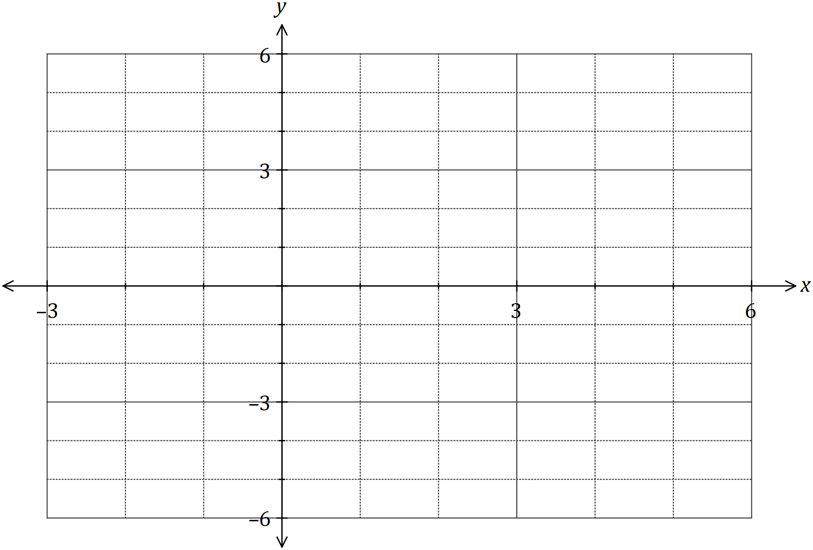

(c) On the axes below, sketch the graph of . (2 marks)



Question 6 (9 marks)

The graph of and its two asymptotes is shown below.



(a) Determine the equation of both asymptotes. (3 marks)

|  |
| --- |
| **Solution** |
|  |
| **Specific behaviours** |
| ✓ vertical asymptote  ✓ writes equation as proper fraction or similar  ✓ oblique asymptote |

(b) On the axes below, sketch the graph of . (4 marks)

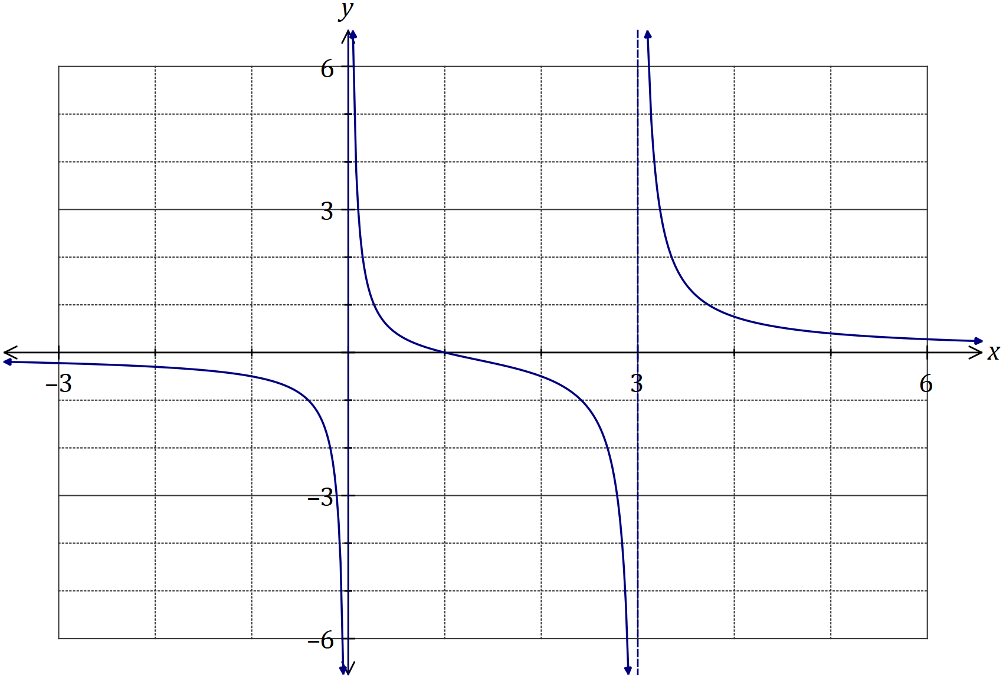

|  |
| --- |
| **Solution** |
| See graph |
| **Specific behaviours** |
| ✓ vertical asymptotes at  ✓ root at  ✓ for  ✓ correct curvature between asymptotes |

(c) On the axes below, sketch the graph of . (2 marks)

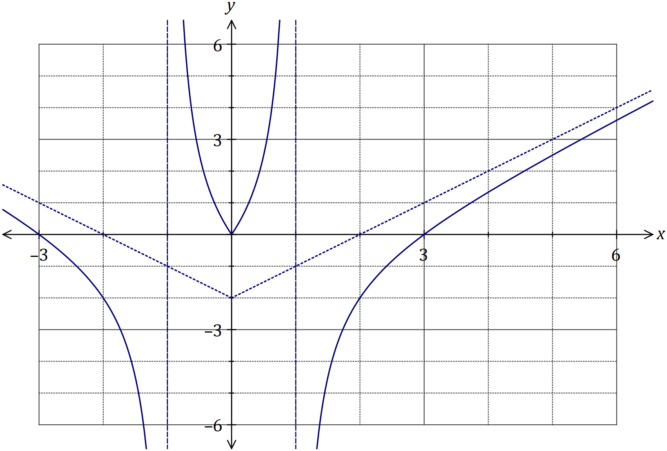

|  |
| --- |
| **Solution** |
| See graph |
| **Specific behaviours** |
| ✓ reflects part of graph in  ✓ all asymptotes and roots |

Question 8 (7 marks)

Function is defined as and function is defined as .

(a) Determine a rule for , the inverse of , and state its domain and range. (3 marks)

(b) Determine an expression for and state its domain. (4 marks)

Question 8 (7 marks)

Function is defined as and function is defined as .

(a) Determine a rule for , the inverse of , and state its domain and range. (3 marks)

|  |
| --- |
| **Solution** |
|  |
| **Specific behaviours** |
| ✓ obtains rule for  ✓ states domain  ✓ states range |

(b) Determine an expression for and state its domain. (4 marks)

|  |
| --- |
| **Solution** |
|  |
| **Specific behaviours** |
| ✓ writes composite function  ✓ notes domain of  ✓ inequality using radicand  ✓ states correct domain |

Question 2 (5 marks)

The graph of is shown below, where .

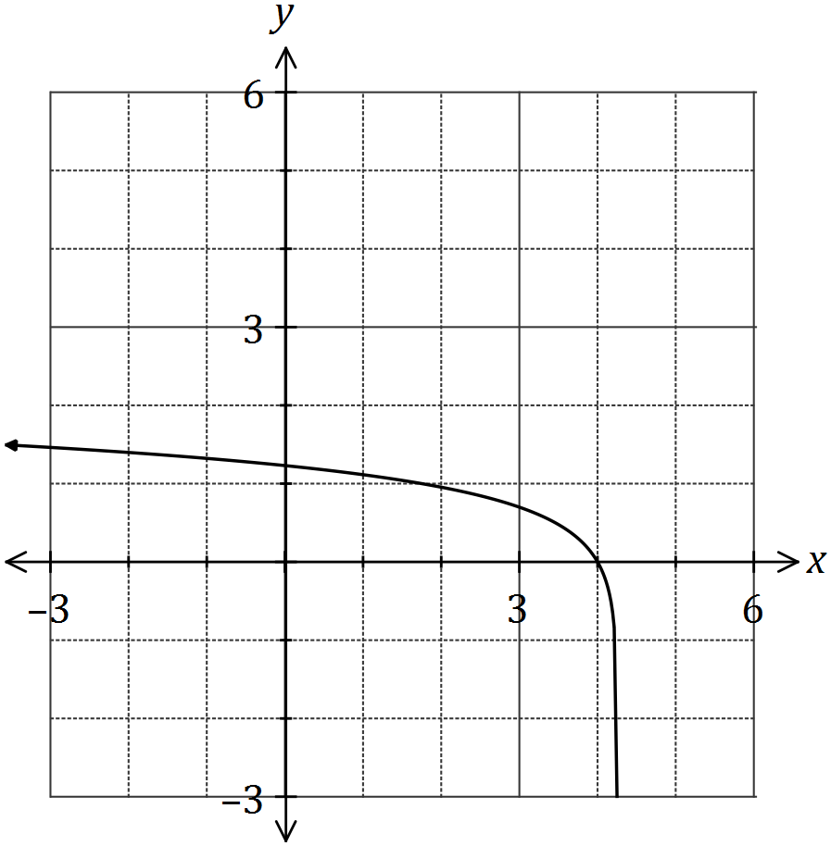

(a) Explain why is a function of over the natural domain of . (1 mark)

(b) Determine a function for the inverse of . (2 marks)

(c) On the axes above, sketch the graph of the inverse of . (2 marks)

Question 2 (5 marks)

The graph of is shown below, where .

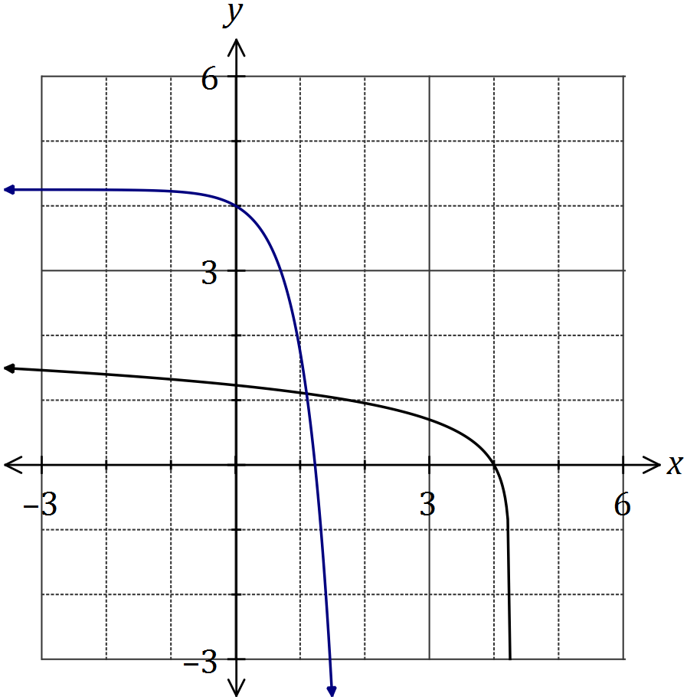

(a) Explain why is a function of over the natural domain of . (1 mark)

|  |
| --- |
| **Solution** |
| A one-to-one relationship clearly exists. |
| **Specific behaviours** |
| ✓ reasonable explanation |

(b) Determine a function for the inverse of . (2 marks)

|  |
| --- |
| **Solution** |
|  |
| **Specific behaviours** |
| ✓ eliminates log  ✓ expresses as function of |

(c) On the axes above, sketch the graph of the inverse of . (2 marks)

|  |
| --- |
| **Solution** |
| See graph |
| **Specific behaviours** |
| ✓ and intercepts  ✓ clearly reflection of in line |

Question 6 (6 marks)

Two functions are defined by

(a) Determine . (1 mark)

(b) Determine a simplified expression for and state the domain and range for this composite function. (5 marks)

Question 6 (6 marks)

Two functions are defined by

(a) Determine . (1 mark)

|  |
| --- |
| **Solution** |
|  |
| **Specific behaviours** |
| ✓ evaluates |

(b) Determine a simplified expression for and state the domain and range for this composite function. (5 marks)

|  |
| --- |
| **Solution** |
|  |
| **Specific behaviours** |
| ✓ correct expression for composite  ✓ simplifies composite  ✓ correct domain  ✓ range: includes  ✓ correct range |

Question 7 (7 marks)

(a) Part of the graph with equation is shown below.

Complete the sketch, clearly indicating the location of any asymptotes. (2 marks)

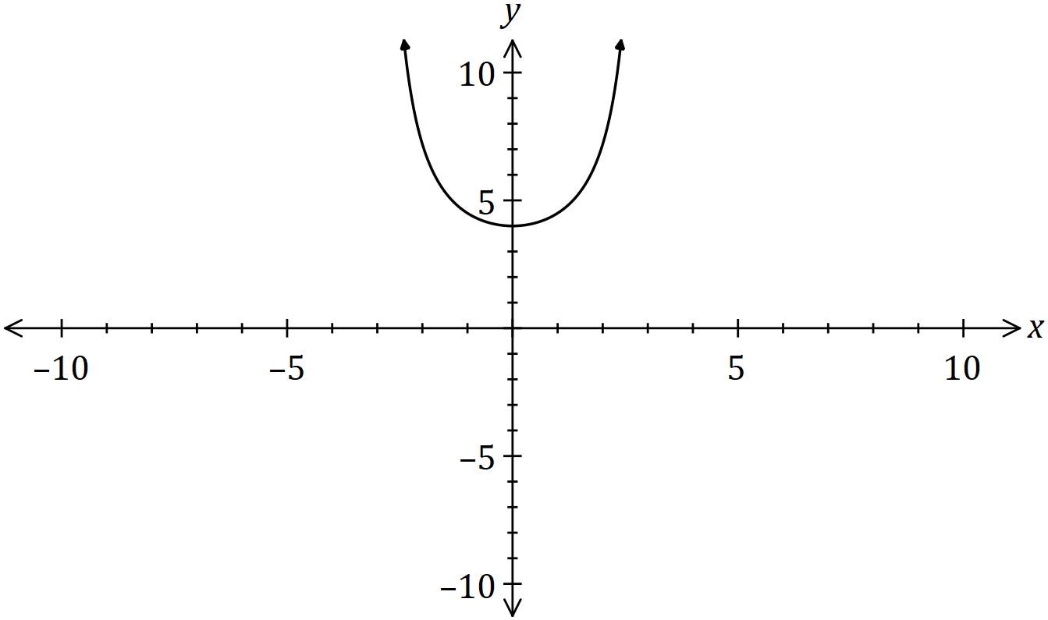

(b) Determine the area bounded by , the -axis, the -axis and the line .

(5 marks)

Question 7 (7 marks)

(a) Part of the graph with equation is shown below.

Complete the sketch, clearly indicating the location of any asymptotes. (2 marks)

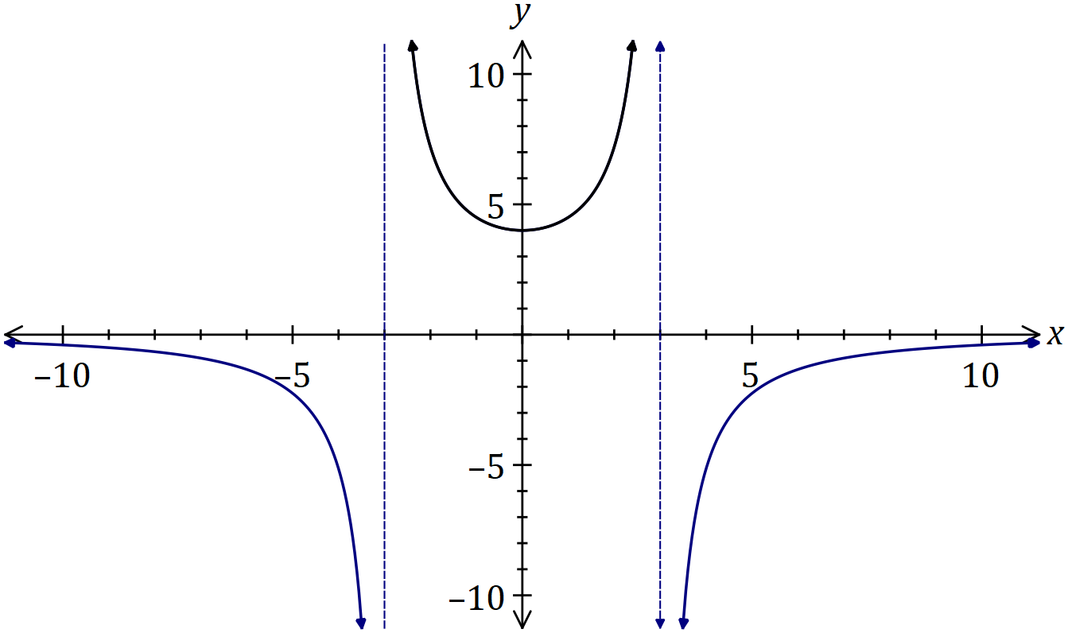

|  |
| --- |
| **Solution** |
| See graph |
| **Specific behaviours** |
| ✓ indicates vertical asymptotes  ✓ general shape |

(b) Determine the area bounded by , the -axis, the -axis and the line .

(5 marks)

|  |
| --- |
| **Solution** |
|  |
| **Specific behaviours** |
| ✓ indicates use of partial fractions  ✓ correct partial fractions  ✓ indicates definite integral  ✓ integrates correctly, using absolute values  ✓ correct area |